

**WECARE Massage & Natural Therapy**

**WEBSITE DEVELOPMENT DOCUMENTATION**

**DEVELOPERS**

* **Dinithi Vithanage**
* **Shemal Ashen Jude Jayawardena Geekiyanage**
* **Yu Liu**
* **Xi ting jia**

Table of Contents

1.0 Project Description 3

Justification for WeCARE project:

1.1 Market Research 3

1.1.1 Target Customers 3

1.1.2 Competition 4

Project Goals:

1.2 Client Meeting Discussions-Project Requirements 4

1.2.1 Main Project Requirements 6

Timeline between milestones:

1.3 Major Milestones 7

Milestone 1 7

Milestone 2 7

Milestone 3 7

Milestone 4 7

2.0 Project scope of the full final-release (User Story) 8

3.0 Project sponsor/client/customer signed 11

4.0 Project development and release ICT infrastructure 13

4.1 Configuration Management/ Version control………………………………………..13

4.2 Project tools. Programming languages/IDEs………………………………………..13

4.3 Testing tools, data and procedures…………………………………………………..13

4.4 Prototype………………………………………………………………………………..14

**1.0 Project Description**

**Justification for project**

WeCARE massage, established in 2015 can be categorized as a family owned business with a total of 6 employees, the primary business goal or service offered is catering to clients that require relaxation services, currently the company has a simplistic informational website that has been created with an online web site development tool namely wix.com.

During further investigation of the website along with the set of client meetings conducted we discovered that the client required a more interactive site and as most of its clients are usually the working-class population of the inner Brisbane city location the site should be accessible on the go. This developed a need for the business to have a responsive website.

Taking it one step further, we as a team suggested in building a massage booking section on to the website as well. Thereby allowing clients to further reduce the time taken to make a call and book an appointment.

This would generate more customers as well as acquire more orders and a more organized method of utilizing the website for the businesses target clientele. Furthermore, the client can book in advance while also saving cost for the company on labour for answering calls for booking.

## 1.1 Market Research

### 1.1.1 Target Customers

In order to create a website that would be successful and engaging the main target customers were identified based on the targeting options below.

**Demographic**

**Age** :18 to 55 years of age

**Gender:** Both Female and Male

**Occupation:** Mainly executives, construction workers, aged clientele

**Income:** Medium Income Range

**Geographic**

Clients are usually based in and around the inner Brisbane city area and as the business is located at the GAP, this is also a primary location client are located

### 1.1.2 Competition

There exists high competition in the wellness therapy industry, and to be on top of the game is utterly important. To have an appealing, fully functional and user-friendly website is a plus point to any user which would result in better customer loyalty and also attract new ones. Wellness spas may have high levels of service extensively, but the attraction of a customer with convenience can be just as important as the core service.

In doing research in and around the area where We Care is located and in consultation with the client there were two main competitors that were identified. After conducting a research on each of their websites the following points were noted.

* **PhysioLogix Therapy Solutions** 
  + Website is not responsive however has a much easier navigation and clearer information structure than compared to WeCare.
* **Ebb & flow - Day Spa** 
  + The website is responsive and does include a very well designed online booking system which s gives them a competitive advantage of WeCare. However, they do not have a membership form which the proposed solution for this project will include to have an all-round website.

**Project Goals**

## 1.2 Client Meeting Discussions-Project Requirements

Based on the requirements by the client the main solution was to revamp the current website therefore during the client meetings held several suggestions were made from our end and the requirements from the client were noted down as well. Below mentioned is a summary of the discussion points.

* The versatility of the web page is essential as a customer would use a number of devices and even screen types to view. To have a responsive website that adapts to such screens and devices will make the service initiation even more pleasant. This will help reduce the time taken to convert an enquiry into a potential sale. Furthermore, in keeping the identified target customers in mind and the competition surrounding the business the need for a responsive website was important.
* The client issues membership cards for customers and those that are regular reach a free service at a certain stage. However, this card is not online for website users to use through. If an active membership card can help customers achieve discounts online, it would assist the success of this business greater than ever before. Therefore, a need for a membership page arose.
* Research pages of specific types of discomforts with corresponding services that are designed for such matters, so that customers, even if confused about what they want, would have a clear vision about what they need. With regards to allergens, if any product does have effects, to have it mentioned so that readers would know what is being used and what is not.
* Displaying pictures and clips with a selection of soothing tunes in order to have a perfect understanding of the wellness spa and the type of professional services they offer, will aid the customer to view and choose, acting as an additional attraction of the website.
* Easy Navigation-‘Bottom Up’ buttons on the page would come in handy since the viewer would not need to scroll all the way up back to the top, instead, with a click of a button, be directed back to the top of the page.
* A website background, which has a stronger appeal on whoever is viewing the website. Instead of having the existing background format, with a creative yet simple scene, the entirety of the website will be attractive to the user.

### 1.2.1 Main Project Requirements

With the above summary of points the main project requirements were listed in collaboration with the client as follows:

* **A fully functioning responsive website** as customers are looking for easy on the go solution
* **A member sign up page** 
  + Member information with the number of visits should be accessible online to the massage therapist thereby making it easier to distinguish the loyal customers thereby providing discounts and member offer based off of this information
* **Contact Us page** 
  + A specific contact us page with the ability for customers to leave a comment or testimonial thereby helping with the promotion of the website and new customers are able to look up the massages that were beneficial to previous clients
* **Gallery of services** along with a description of each service along with the ailment in will prevent after. This is currently missing from the website.
* **Careers Page**- Since the business is growing in size the client requested for a careers page thereby allowing applicant to mail across their CV.
* **Online Booking System**- The major requirement of the website would be to provide customers with the service of booking online with all the details of the massages and the therapists within this system.

**Timeline between milestones**

## 1.3 Major Milestones

The project will be shown to the client in phases and at the end of each phase any changes will be taken towards the next iteration.

The major milestones of the project would be as follows, we have divided the milestone into four and thereafter subdivided sub milestones within each.

### Milestone 1

Initial creation of the overall website pages with an overall responsive website.

* + Include proper navigation with bread crumbs
  + Simple user navigation options with hyperlinks to navigate

### Milestone 2

Database connectivity with regard to all the pages that require sign up forms or information to be store

* Member Sign Up Page
* Careers page connectivity

### Milestone 3

* + Booking engine Connectivity

This will be the main part of the website that would be the key design feature.

### Milestone 4

* + Overall website testing.
  + Careers page connectivity

# 2.0 Project scope of the full final-release (User Story)

|  |  |  |  |  |  |  |
| --- | --- | --- | --- | --- | --- | --- |
|  |  | **Project Name:** | WeCare Massage Therapy | |  |  |
|  |  | **Developers:** |  | |  |  |
|  |  | Yu Liu | |  |  |
|  |  | Shemal Jayawardena | |  |  |
|  |  | Dinithi Vithanage | |  |  |
|  |  |  | Xi ting Jia | |  |  |
|  |  |  |  |  |  |  |
| **User stories log** | | | | | | |
| **Release** | **Nr** | **User Story** | **Description** | **Priority** | **Time (days)** | **Status** |
| **Alpha ICT1 12 weeks** | 1 | **INFORMATION GATHERING** | Initial Communication with the client | 10 | 3 | COMPLETE |
| 2 |  | Current website discussion and future requirements validation | 10 | 2 | COMPLETE |
| 3 |  | Discussion and confirmation of required pages and features | 9 | 4 | COMPLETE |
| 4 |  | Site Visit | 5 | 1 | COMPLETE |
| 5 | **PLANNING** | Project deliverable time plan- discussion | 8 | 4 | COMPLETE |
| 6 |  | Signing Client Agreement | 10 | 2 | COMPLETE |
| 7 |  | Development tools, languages, CMS integration discussed | 9 | 3 | COMPLETE |
| 8 |  | Internal project time line formation | 9 | 3 | COMPLETE |
| 9 | **DESIGN** | Site plan finalization | 10 | 3 | COMPLETE |
| 10 |  | Photo Accumalization |  | 3 |  |
| 11 | **DEVELOPMENT** | Responsive Design of site | 10 | 4 | IN PROGRESS |
| 12 |  | Main Pages of the website constructed with main links | 10 | 6 | IN PROGRESS |
| 13 |  | Booking Section Creation | 10 | 5 |  |
| 14 |  | Database connectivity | 10 | 5 | TO BE COMPLETED |
| **Beta ICT2 5 weeks** | 15 | **DEVELOPMENTS** | Booking Engine Further Improvements | 10 | 8 | TO BE COMPLETED |
| 16 |  | Proper Navigation | 8 | 4 | TO BE COMPLETED |
| 17 |  | SSL Connectivity for security | 10 | 2 |  |
| 18 |  | Entire Functionality within website | 10 | 5 | TO BE COMPLETED |
| 19 | **TESTING AND DELIVERY** | Develop Test Cases | 10 | 7 | TO BE COMPLETED |
| 20 |  | Testing Carried Out | 9 | 7 | TO BE COMPLETED |
| 21 | **MAINTANANCE** | Website User Manual | 10 | 6 | TO BE COMPLETED |
| 22 | Passwords | TO BE COMPLETED |
| **Final ICT2 5 weeks** | 23 | **BUG FIXES** |  | 10 | 6 | TO BE COMPLETED |
| 24 |  |  |  |  |  |
| 25 | **MAINTANANCE** | Website User Manual- Video Version | 10 | 3 | TO BE COMPLETED |
| 26 | Passwords | TO BE COMPLETED |
| 27 |  |  |  |  |  |
| 28 |  |  |  |  |  |
| 29 |  |  |  |  |  |

# 3.0 Project sponsor/client/customer signed

# 4.0 Project development and release ICT infrastructure

## 4.1 Configuration Management/ Version control

* GitHub to record every step of website designs help remember and recovery.
* SLACK and WhatsApp for community and discussing our project, and make communication with clients.

## 4.2 Project tools. Programming languages/IDEs

o Dreamweaver as basic designing tools for WeCare.

o PHP for all global part control, like navigation bar, which in every page, this will easy to edit and change in feature

o SQL, WeCare website need database system to recording clients detail.

o HTML5 for basic designing, when finish the main 3 or 4 pages will change html files to PHP style.

## 4.3 Testing tools, data and procedures

Clients Use Domain Name to open website as a visitor to check all pages and forms response.

Domain Hosting to create database recording customers details

* Create to videos with treatment documents for clients in treatment page
* one for every visitor, descript how to use this website find out everything they need,
* another one for owner, tell the owner how to use and change, control and feature improve this website.

## 4.4 Prototype

**ER diagram**

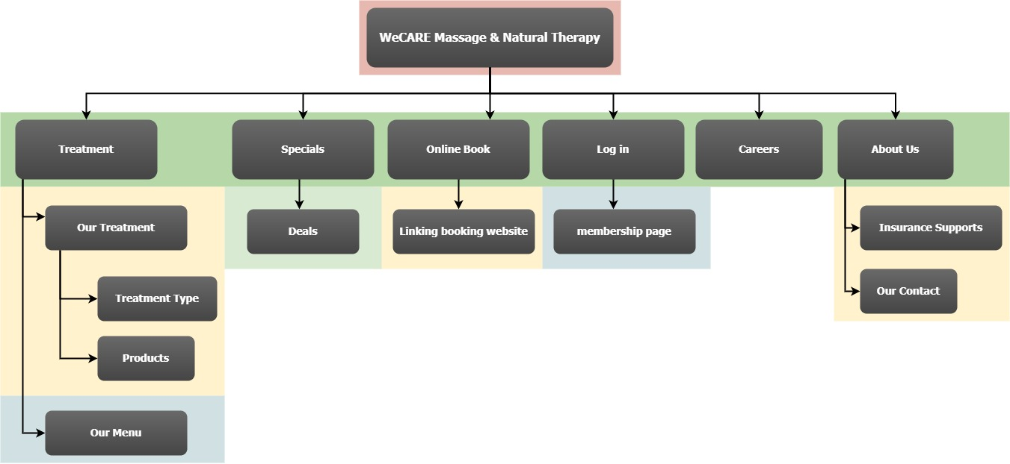

The following home page design was shown to the client as a prototype before the development phase and feedback was received accordingly.

**Home page View**

